Systems of two or three linear equations can easily be solved **using four basic methods**:

1. Graphing
2. Substitution
3. Elimination
4. Matrix Algebra (Gaussian reduction or the A-1 methods)

Example for Methods 1-3 (Method 4 will be taught subsequently).



Consider the system of 2 equations:

1. 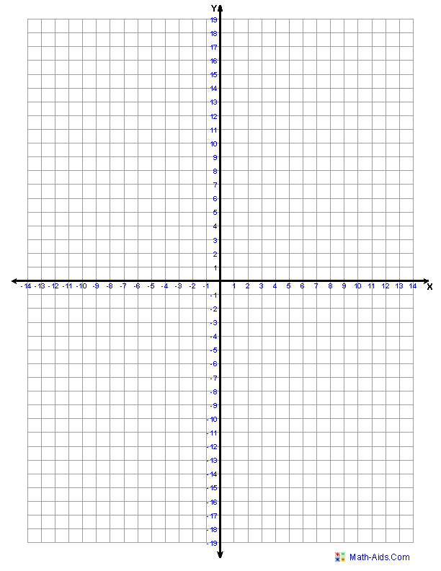Graphing: Just graph the equations and observe where they intersect.

Answer: x = ___________, y = ______________

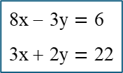

1. Substitution: (always works)



1. Elimination: (works only for linear equations)

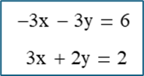

Submit for grade, solution(s) for the following system of equations:

1. Provide a graphical solution:

Answer: x = ___________, y = ______________

1. Solve using substitution:

1. Solve using elimination: