1. Given the function z(x) = x3 - 3x2 + x – 3 shown on the graph in Figure 1:
2. Explain why z(x) is a function.

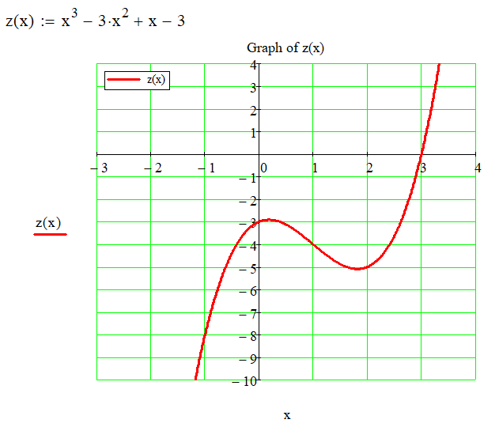

Figure 1

1. In interval format, write the function z(x)’s:
2. Domain
3. Range
4. Relative maximum(s)
5. Relative minimum(s)
6. The inflection point(s) of z(x) [look this up if necessary)
7. End condition as x → - ∞
8. End condition as x → + ∞
9. y axis intercept
10. x axis intercept
11. A graph of a function

    AI-generated content may be incorrect.A graph of a function

    AI-generated content may be incorrect.Indicate whether each of the following x-values is a relative maximum, relative minimum, or neither.
12. A screenshot of a math test

    AI-generated content may be incorrect.Answer the multiple-choice question to the right **AND** accurately sketch the score equation onto figure 2 with the acceptable score area shaded in. Adjust axes numbering as necessary.

Label your graph completely and correctly!

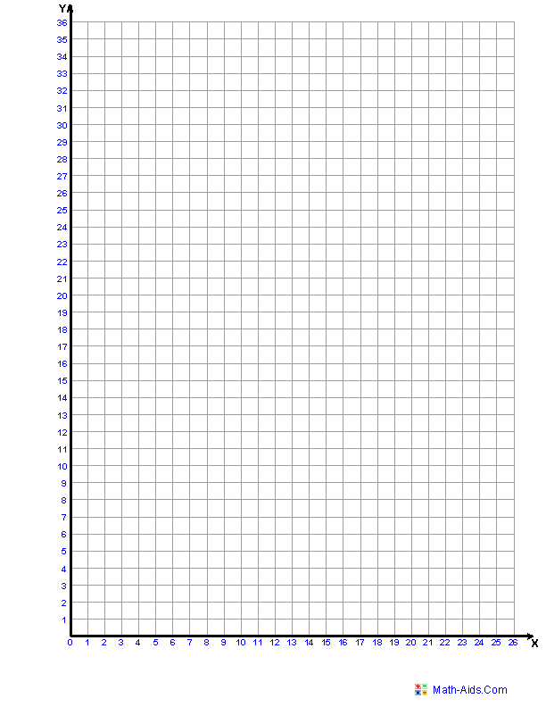

Figure 2

1. Given the system of inequalities:  **3 x + 4 y > 10**

**12 + 6 X > - 2 y**

SKETCH THE INEQUALITIES AND SHADE IN THE SIMULTANEOUS SOLUTION AREA in Figure 3.

Figure 3

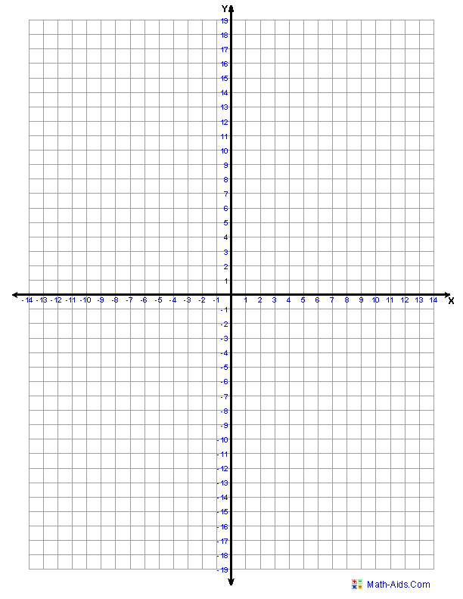

1. Solve and sketch the solution for the following absolute value equality:
$$-3\left|4x-4\right|= -21$$

2. Solve and sketch the solution for the following absolute value inequality:

In math and logic, the symbol for: a **conjunction** is **∧** (read as "and"), representing a statement that is true only if both parts are true. When in proper form, this occurs when |X| < P [Conjunction: where the solutions “OVERLAP,” if any overlap exists.]

A **disjunction** is **∨** (read as "or"), representing a statement that is true if at least one of the parts is true (inclusive). WHEN In proper form, this occurs when |X| > P. [Disjunction: the “UNION” of the solutions.]

$$-5\left|3x+10\right|>-25$$

1. Solve and sketch the solution for the following absolute value inequality:

$$\frac{|2X-4|}{3}>10$$