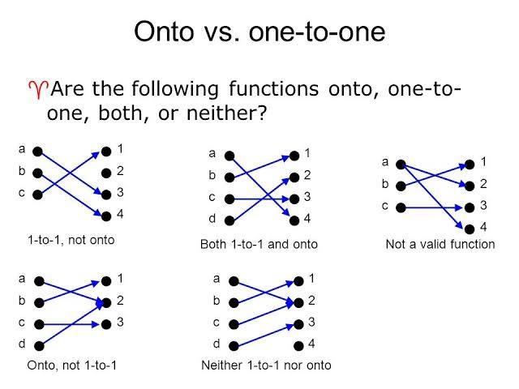

"One-to-one" and "onto" are terms describing characteristics of mathematical functions, particularly in linear algebra, that describe how elements from the domain map to the codomain (or range). A function is one-to-one (injective) if every output has a unique input; no two different inputs produce the same output. A function is onto (surjective) if every element in the codomain is an output for at least one input; the function's range covers the entire codomain. A function that is both one-to-one and onto is called a bijective function.

One-to-One (Injective)

* **Definition:** Each element in the domain maps to a unique element in the codomain.
* **Visual:** Imagine a function where each point in the domain has only one distinct "target" in the codomain.
* **Test:** If you can find two different inputs that produce the same output, the function is not one-to-one.
* Domain: set of x values to be evaluated by the function.
* Range: the set of y values that **ACTUALLY RESULT** from the evaluation of the function.
* Codomain: the set of all the y values that **COULD POSSIBLY RESULT** from the evaluation of the function.

* **Example:** In the function f(x) = 2x, each unique input 'x' will produce a unique output. You won't find two different 'x' values that give the same '2x' value.

For a better description, view: <https://www.youtube.com/watch?v=m8wsG8x_Zj0&t=319s>

