Activity Guide - Multi-screen App

Multi-screen App
You will be creating your own multi-screen app to practice designing user interfaces and writing event-driven programs. You have a lot of freedom to choose what your application will be but some ideas might include:

- A personal app about you and your hobbies / interests
- A “Top 3” app for a category of your choosing
- An informational app for an organization or club
- A flash card app for studying for quizzes
- A short “choose-your-own adventure” game
- An app with a different game on each screen

Requirements
Your application must have the following components:

- Your app must have some kind of purpose
  - Even if the purpose is simple like “Celebrating all my favorite foods to eat”, there must be an underlying purpose that thematically ties the whole thing together.
  - The title of your app should make it pretty clear.
- Your app will have at least 4 screens.
- Your app should include text, images, and buttons (and optionally sound).
- No “getting stuck” on a screen.
  - It should always be possible to navigate from a screen in your app to some other screen.
  - The user should also be able to “get back to the start” somehow. There are many ways to do this (e.g., screens go in a cycle, or every screen can navigate back to the home screen, etc.) but you should make sure you plan accordingly.
- Your program code should follow good style, particularly by giving UI elements descriptive and meaningful IDs.
- Your user interface should be intuitive to use.

Process
- Choose the theme and purpose of your app.
- Complete the Planning Guide to decide how you will display your information.
- Informally Share the sketch of your idea with a classmate to get some basic feedback and to see if they have any ideas you hadn’t thought of. Possible discussion points:
  - Does the way users navigate through pages intuitive?
  - Is the design / layout clear and present the information well?
  - Anything you would add? Anything you would take out?
- Program your app following the plan you develop in the Planning Guide.
- Peer Review at least one of your classmates’ apps using the Peer Review Rubric.

Planning Guide

Outline Your App
You will be sketching out the layout of your application using the rectangles below. Each rectangle represents a screen of your app. For each screen you should:

- Decide what information will be included on that screen.
- Give the screen a descriptive ID.
- Add any notes about the content that will be featured in that screen.
- Within each rectangle, draw the elements that will appear in that screen.
- Draw arrows to / from your screen showing how a user will be able to navigate through the app.

Screen ID:

Notes:

Screen ID:

Notes:

Screen ID:

Notes:

Screen ID:

Notes:

Outline Example

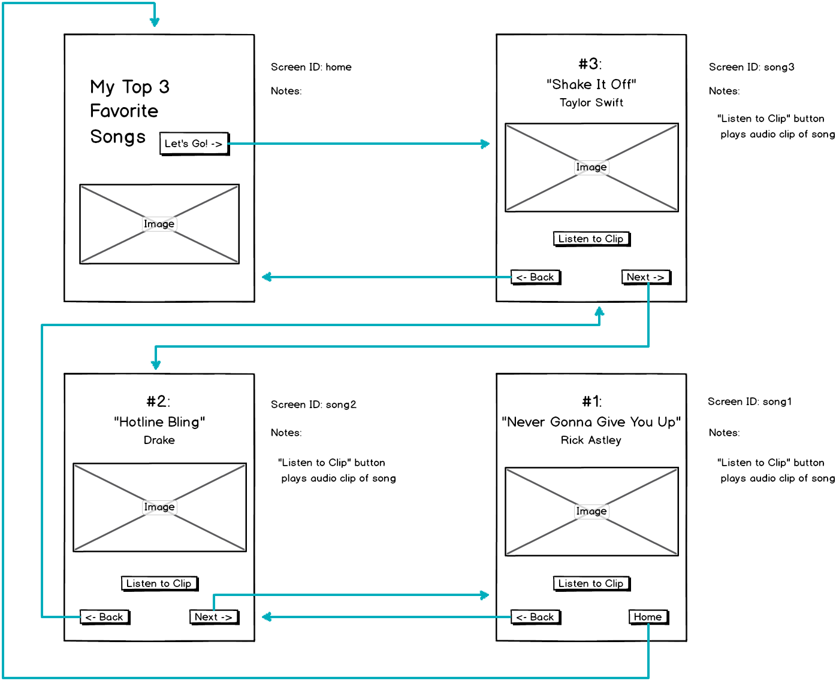

Peer Review Rubric

Project being reviewed:

Reviewer:

Criteria | Yes | Almost | No | Comments
Intended purpose of the app is clear
Project includes at least 4 screens.
Application includes images, text, and buttons. (bonus points for sound).
You cannot get “stuck” on any screen. It is always possible to get to the rest of the app.
Text on screen is clear and descriptive.
Element IDs are descriptive and meaningful.
(Look at the code.)
The app is visually appealing and the user interface is intuitive to use.

