Activity Guide: Rapid Research - Data Innovations

Project Overview: Data Innovations
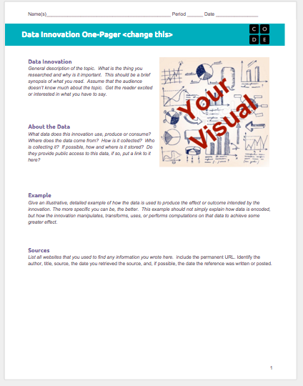
In this small project, you will quickly research a computing innovation of your choice and present a “one-pager” about it. The computing innovation should be one that produces, uses, consumes or is “driven” by data in some way.

The One-Pager
In the professional world, it is common to ask someone to do a bit of online research and then prepare a one-page summary or “one-pager” to show the rest of the team or colleagues about the highlights of what you found. Here you will prepare a one-pager that explains how some technological innovation uses data. We have prepared a template for you here: TEMPLATE - Data Innovation One-Pager After conducting your research, you will fill it out.

General Process & Requirements
- Review the One-Pager Template and the Rubric below.
- Choose your innovation using the guide below to help.
- Conduct your research by following the Research Guide below.
- Complete the one-pager.

Choosing Your Innovation
You should choose an innovation related to big data you find personally relevant or interesting. For the purposes of this project, you may need to use a broad definition of an “innovation,” and it doesn’t necessarily mean that it has to be a new invention. In particular, we’re looking for an innovation that uses data.

Brainstorming:
Start by simply going to your favorite search engine and entering the name of a thing you are interested in, followed by the word “data” or “big data.” For example: “soccer big data,” “shopping big data,” “music big data.” It might take some poking around, but you will find a few interesting things.

Make sure you can easily find at least one or two reputable resources for your innovation and how it uses data.

Other Ideas:
- Smart grids, smart buildings, smart homes
- The data behind your favorite app
- Online shopping trends/recommendations
- Crowdsourcing
  - Crowd source inventions and funding (Kickstarter, Quirky, GoFundMe)
  - reCAPTCHA
  - GWAPs - Games With A Purpose
- Assistive technologies - aiding human vision, hearing, movement, etc.
- Machine learning
- Sports analytics
- Any kind of science: physics, biology, chemistry, astronomy, etc.

Research Guide - Data Innovation

Conducting Your Research
You already have some practice finding good resources online. You’ll want to find recently published documents from authoritative sources. There is no need to use overly technical documents, but keep an eye out for familiar terminology and topics.

Key Information to Find
- When your innovation was created and by whom
- Why it was created. What was the context in which your innovation was created (e.g., other technologies currently available) and the motivation for creating your innovation
- How your innovation works (keep the technical details to a level you’re comfortable with)
- The impact of your innovation on society, the economy, and culture (look for actual examples to back up your claims here)

Use the tables below to keep track of your information; you can also add more if you like. You’ll need to include at least 2 sources of information but you can use more.

My Innovation: _________________________________________________________________

Reference Name:  Year Published: | URL:
Key Information

Reference Name:  Year Published: | URL:
Key Information

Reference Name:  Year Published: | URL:
Key Information

Rubric - Data Innovation One-Pager

One-Pager Template
- Click this link to see the template for the one-pager.
- You should make a copy of that document and fill it out, making sure to keep everything to one page.

One-Pager Rubric

Component | 1 | 2 | 3 | Score
Sources & Visual
Sources | Research Guide includes references to fewer than two sources and the source listed is not recent and authoritative. | Research Guide includes references to fewer than two sources or the sources are not recent and authoritative. | Research Guide includes references to at least two recent, authoritative sources.
Visual | Visual does not substantially contribute to expanding the understanding of the innovation provided in the written responses. | Visual may be appropriate but largely repeats information in the written responses, or is only loosely related to the innovation. | Visual is well chosen and enhances or augments the information in the written responses.
Written Responses
Data Innovation Description | Topic description does not provide a clear explanation of the topic. Description makes limited or inaccurate use of vocabulary and concepts encountered in this unit. | Topic description provides an adequate explanation of the topic but may lack sufficient detail. Description makes adequate use of vocabulary and concepts encountered in this unit. | Topic description is clear, comprehensive, and rich with details. Description makes appropriate use of vocabulary and concepts encountered in this unit.
About the Data | A brief description of the data used by this innovation is given but only includes superficial detail or generic descriptions. | A description of the data used by this innovation is given but lacks sufficient detail to give a clear picture of exactly how the innovation uses data or what is innovative about it. | A clear description is given of what kind of data the innovation uses, how it’s collected, and by whom. It also explains how the innovation uses, produces, or consumes this data.
Example | The example is only loosely connected to the innovation or simply repeats information from the previous two responses. It is not clear that the student has an understanding of how the innovation works or uses data. | The example is related to the innovation but lacks sufficient detail to give much depth of insight to the innovation, beyond the descriptions of the innovation and data itself. The response might indicate a student’s understanding is not strong. | The example provided clearly indicates the student's strong understanding of how the innovation uses data to achieve its desired results. The example gives insight into what the innovation does or how it works.

